Representation of non-additive predation mortality in Ecosim

Ecosim partitions mortality rate over time into predation, fishing, and “natural” components, where the natural mortality rate is estimated by default as the Ecopath Mo rate (P/B)*(1-EE). But there is good reason to believe that in many cases, the same stress factors that cause vulnerability to predation (hunger, senility, parasites and diseases) would cause higher natural mortality rate if predation rate were lower, i.e. predators tend to remove prey that are more vulnerable to predation because of the stress factors and many of these prey would have died anyway if not eaten. Such “nonadditive” predation effects (Walters and Christensen, 2019) can be represented in Ecosim by setting a single parameter (on the Ecosim Group Info tab) for each group, Padd, representing the proportion of the predation mortality rate that would have occurred anyway if predation were absent.
Given Padd, Ecosim sets the “other” or natural mortality rate Mt at any time step to the value
Mt=Mmax/(1+kPt) (1)
where Mmax=Mo+(1-Padd)Mp using Ecopath base predation rate Mp, Pt is relative predation rate (predator consumption rate of the group divided by ecopath base predation rate) in time step t, and k is calculated so as to give Mt=Mo when Pt=1 (k=Mmax/Mo-1). Equation (1) is derived from the basic vulnerability exchange dynamics equation of Ecosim, by assuming an additional “nonadditive” mortality rate on the Ecosim vulnerable biomass pool at any time. This is an improvement on the approximation of simple linear change in Mt suggested by Walters and Christensen (2019), since it is derived from the full vulnerability dynamics equation.
As shown in the Figure below, increases in assumed Padd cause the Ecosim total Mt to vary from simply additive (Padd=1) to nearly constant for cases where predation rate declines to below the Ecopath base rate.
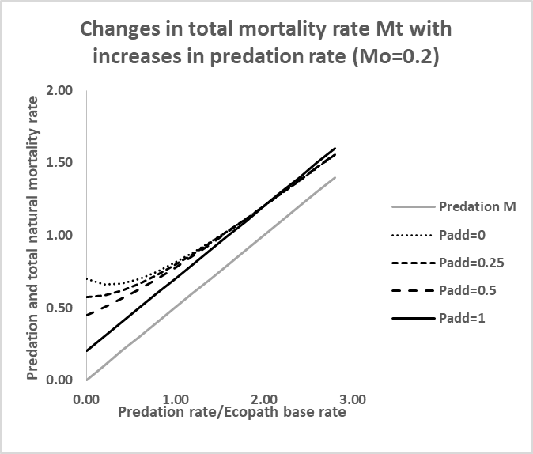
(from “simple nonadditive predation model.xlsx”)
Interestingly, when Padd is assumed to be very low the model actually predicts decreasing total mortality rate Mt as predation rate increases. This has long been a basic prediction in predation ecology, i.e. modest levels of predation can actually increase population “health” (reduce natural mortality rate) by removing "unhealthy" individuals from the prey population.
Importantly, assuming low Padd values for smaller “forage” species results in much less reduction in Mt when predator abundances decline (e.g. due to harvesting) than would be predicted if Mt were assumed to remain at the additive, relatively low Mo estimated in Ecopath. This means that such forage species exhibit much less increase in net productivity (biomass growth rate minus natural mortality rate) than would be predicted under the additive (Padd=1.0) mortality assumption typically used in ecosystem modeling.
Reference
Walters, C. and Christensen, V., 2019. Effect of non-additivity in mortality rates on predictions of potential yield of forage fishes. Ecological Modelling, 410, p.108776.

